Background information for IODP Expedition-355
(Arabian Sea Monsoon)

Name of the expedition: Arabian Sea Monsoon
Drilling Vessel: D/V JOIDES Resolution
Expedition Schedule: March 31 - May 31, 2014
Embankment /Dismemberment: Colombo/Mumbai

Summary of Proposal:
A detailed understanding of interactions between solid Earth and climate is an important area for geoscientific research and has been appropriately emphasized in the IODP Science Plan. The continental margin of India adjoining Arabian Sea offers a unique opportunity to delineate the relative role of climate and tectonics and the net impact on weathering and erosion of Himalaya. We propose scientific drilling in the Arabian Sea to understand co-evolution of mountain building, erosion and climate over various time scales. The SW Monsoon is one of the most intense climatic phenomena on Earth. Its long term development has been linked to the growth of high topography in South and Central Asia. Conversely, intensification of the summer monsoon rains is linked to the tectonic evolution of the Himalaya and Tibet, not least the exhumation of the Greater Himalaya and to the rate of plate convergence. Weathering of Himalaya has also been linked to the long-term drawdown of atmospheric CO2 during the Cenozoic, culminating in the onset of Northern Hemispheric Glaciations. No other part of the world has such intense links between tectonic and climatic processes. Unfortunately these hypotheses remain untested due to limited information on history of erosion and weathering. This cannot be accomplished onshore because the foreland basin records are disrupted by major unconformities and depositional ages are hard to determine with high precision. Here, we propose to recover long records of erosion and weathering from the Indus fan that will allow us to establish links between these processes and the oceanographic history of the region already reconstructed from drilling on the Oman margin. Such records can further be correlated to structural geological data in the Himalaya and independent records of evolving Tibetan Plateau to estimate sediment fluxes and erosion rates. The proposed drilling will be accomplished within a regional seismic stratigraphic framework, allowing a robust estimation of sediment budget along with quantitative estimates for weathering fluxes. Drilling through the fan base and into the underlying basement will permit additional constraints to be placed on the nature of crust in the Laxmi Basin (Eastern Arabian Sea). This is highly significant for understanding problems of global interest such as paleogeographic reconstructions along conjugate margins in the Arabian Sea and models of continental breakup on rifted volcanic margins.
Scientific Objectives:
- Testing whether Greater Himalayan exhumation correlates with the proposed monsoon intensification after 23 Ma.
- Determining if the monsoon strengthened or weakened at 8 Ma,
- Dating the age of the base of the fan to constrain the timing of upliftment of Himalaya and Tibet plateau.
To decipher the nature of basement rocks in the Laxmi Basin (Eastern Arabian Sea) for constraining early seafloor spreading and its relation to the emplacement of the Deccan Flood Basalts. This objective would have significant implications for precise paleogeographic reconstructions in the northwest Indian Ocean.

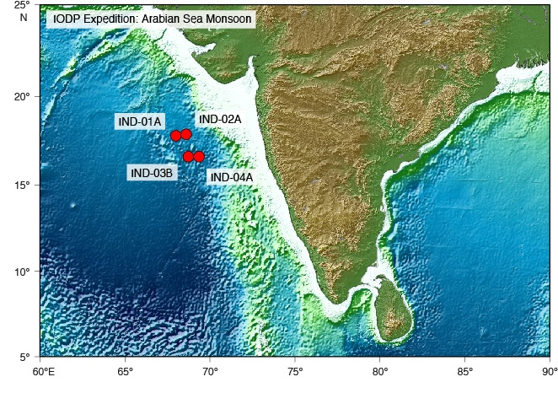

Drilling Plan
Site Name | Position  (Degrees) | Water Depth (m) | Penetration (m) |  |  | Brief Site-specific Objectives
Site Name | Position  (Degrees) | Water Depth (m) | Sed | Bsm | Total | Brief Site-specific Objectives
IND-01A  (W5-SP9200)  IND-02A  (W5-SP10500)  IND-03B  (W6-SP11755)  IND-04A  (W6-SP12850) | Arabian Sea  (67.995875 E 17.793544 N)  Arabian Sea  (68.602208 E 17.881136 N)  Arabian Sea  (68.84552 E 16.62134 N)  Arabian Sea  (69.358589 E 16.614744 N) | 3461  3446  3629  3622 | 690  590  1451  900 | 0  0  100  50 | 690  590  1551  950 | To recover high resolution pre-Miocene records.  To provide high resolution weathering and erosion records on millennial scale.  To target the base of the fan and the basement for obtaining records of more than 23 Ma. Besides, to constrain the paleogeographic reconstructions and continental break-up at rifted margins.  To target the base of the fan and the basement for obtaining records of more than 23 Ma.

-----------------------------------------------------------------------------
Proposed Work under IODP Expedition-355
Please submit your proposed science plan in brief with a clear justification that how your proposed plan would contribute to the broad science objectives of this expedition.

- Proposed Title of Work:

- Major Discipline:

- Sub Discipline:

- PI Name :

- Institute:

- Co-PIs:

- Collaborating Institutions:

- Objectives:

- Summary of Proposed Work:

- Role of Co-investigators:

- Work Plan and Methodology:

- Expected Outcome:

- Facilities/equipments existing with the PI and Co-PIs:

- Facilities/equipments required for the proposed work and time frame to obtain these:

- Funding requests including equipment, if any:

- Manpower Requirement, if any:

- Sample requirements:
(Samples details to be provided in the sample request section)
- Onboard participation requirement, if any:
In case participation is proposed as shipboard party, please see the section Shipboard Participation.
- CV of the PI and Co-PIs: (kindly enclose your brief CV detailing your scientific specialization and scientific publications)
-------------------------------------------------------------
Sample Request
Please visit the site for reference: DO NOT SUBMIT REQUEST ONLINE
http://smcs.iodp.org:8080/smcs/portal/IODP
- Details of Proposed Plan : (…………………. )
- Role of Co-Investigator : ( ………………)
- Sample Description: Expedition, Site, Hole, Core, Section, Depth/interval etc.
- Sample Type:
- Sample Volume:
- Sample interval or Sample depths: such as each 10 cm, 100-102 cm , etc.
- Onboard data measurement required for your samples: (Select the measurements given in list is Excel format at http://www.ncaor.gov.in/iodps/display/289-apply-to-sail )
- If any specific measurement is required for your sample:
- Expected number of samples:
- Sample Handling Instruction: such as store at 4°C etc.,
- General comments: Such as required the samples only from Ash bed if any, only Hard rock samples, only top 100 cm samples etc.

-----------------------------------------------------------------------------------------
Shipboard Party Nomination
For details please visit our site
http://www.ncaor.gov.in/iodps/display/289-apply-to-sail

- CONTACT INFORMATION (Please keep us informed of any changes in the following information)

  - Name (first, middle, last) :

  - Institution:

  - Department:

  - Institution Address:

  - Telephone(Work) : (Home):

(Fax) :

  - Email Address :

  - Present Title :

  - Country of Citizenship: :

  - Place of Birth : Date of Birth

  - Gender:

  - Passport No.: Place Issued :

Date Issued: Exp. Date :

  - Education (Highest degree - PhD., M.S., or B.S.) :

  - Are you currently a student? : (If yes, see note below)

Note: Applications from graduate students include a letter from their primary advisor, documenting the student's scientific experience and detailing how participation on the cruise would fit into their graduate degree program.

- EXPEDITION INFORMATION

Expeditions of Interest (please limit selection to no more than three):
  - Expedition Number: 355 Title: Arabian Sea Monsoon

  - Platform: Riser JOIDES Resolution __ MSP Participation: ________ Partial* Shorebased*

Provide detail of proposed participation in an accompanying letter)

  - Reason(s) for Interest:

  - Personal and/or scientific references (name and address) .

1.

2.

  - Previous DSDP/ODP/IODP involvement and nature of involvement (expedition participant, shore-based participant, etc.) :

- ATTACHMENTS

  - Attach curriculum vitae which includes a publication history

  - Please fill out the attached "Field of Expertise" form
- FIELD OF EXPERTISE

Please mark an “X” by your area(s) of expertise.

- _ Biologist
- _ Microbiologist
- _ Inorganic Geochemist
- _ Organic Geochemist
- Geophysicist
- Hydrologist
- Logging Scientist
- Oceanographer
- _ Paleomagnetist
- Paleontologist (Diatom)
- _ Paleontologist (Dinoflagellate)
- Paleontologist (Foraminifer - Benthic)
- Paleontologist (Foraminifer - Planktonic)
- _ Paleontologist (Megafossil)
- _ Paleontologist (Nannofossil)
- Paleontologist (Phytoplankton)
- Paleontologist (Radiolaria)
- Paleontologist (Silicoflagellate)
- _ Palynologist
- _ Petroleum Geologist
- _ Petrologist
- _ Igneous Petrologist
- _ Metamorphic Petrologist
- _ Physical Properties Specialist
- _ Sedimentologist
- Seismologist
- _ Stratigrapic Correlator
- Structural Geologist
- Downhole Measurements

-------------------------------------------------------------------------------------------

